

# Scan with your smartphone



Check out the CE Cole Math wiki page! You will find a wealth of math information, activities, and resources here!

* Math games
* Math skills practice
* Flashcards
* Printable math worksheets for extra practice
* Printable graph/dot….paper
* Printable manipulatives
* Instructional videos
* And much more!

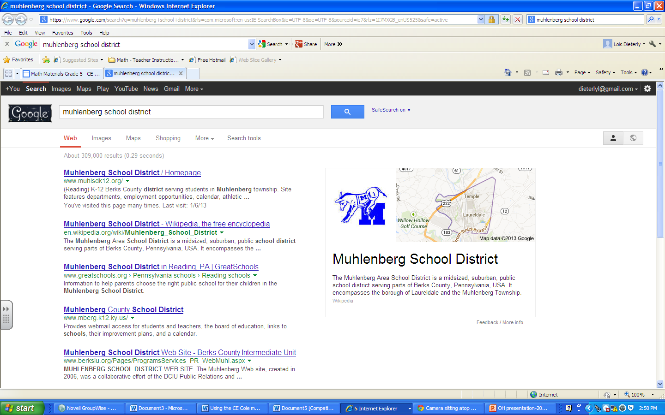

http://sites.google.com/site/cecolemath

# CE Cole Intermediate School

Where math is just a click away!

## Math Wiki page information



### What you’ll find on the math wiki page:

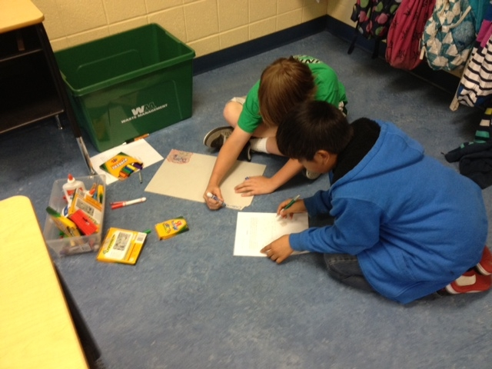

**http:sites.google.com/site/cecolemath**

# CE Cole Math wiki:

If you are looking for help on work that you’re doing in the classroom, you can access short instructional videos by clicking on the **Math Materials** link for your grade level. Information is listed by topic and lesson number. You will see a highlighted five-digit code that always starts with LZ (not case sensitive) and followed by 3 numbers. Clicking on the code for the video that you want will take you to the general site for these math videos. Type that five-digit code into any search box on the learnzillion site and click ENTER to access the video.

### Accessing instructional videos

#### Pencasts

Pencasts may also help with modeling of math concepts. At this point, pencasts are simply listed in the order in which they were uploaded to the site. More organization is coming! Stay tuned!

#### Math Skill Games

Test your math skills by playing jeopardy-like games or games modeled after the game show, So You Want to Be a Millionaire. Drive a racecar on a track on which the speed of the car is determined by how fast you can answer math problems. Squirt virtual water on objects by determining the angle degree that is necessary to aim correctly! These are just a few of the math skill games and interactive activities available on the CE Cole Math wiki page!



Math is fun!!