Chapter 9:
The Era of Thomas Jefferson
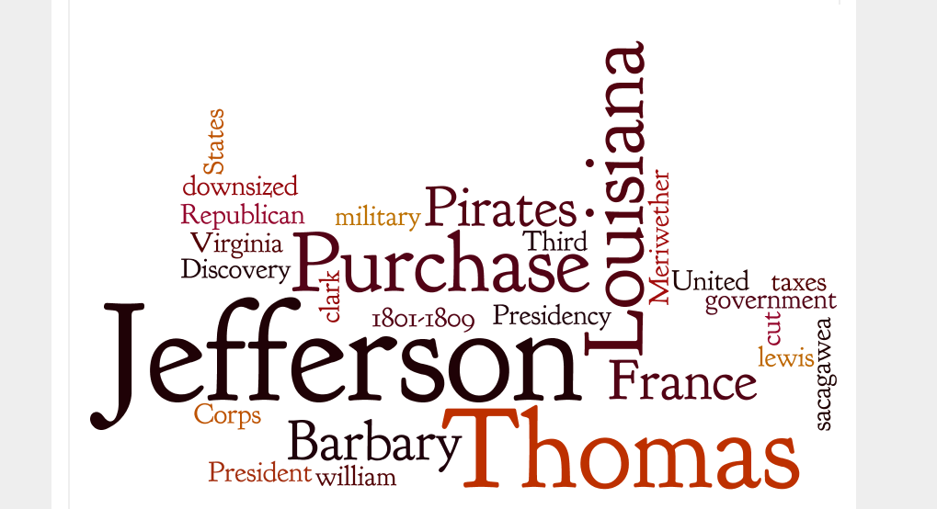

Essential Question: How do nations settle differences?

