Name: __________________________________ Period: ____
Chapter 9 Exam Study Guide
Directions: Complete the following questions on the study guide to the best of your ability. Then use this study guide to study for the upcoming unit test. Also study your notes, textbook, and any vocab and worksheets you did in class. (Pages 308 to 335)
- In the election of 1800 who were the candidates? Who won the election? (circle who won) (310)
Republican Candidate - Federalist Candidate -
- What was the Sedition Act? How did Jefferson feel about the people imprisoned under the act? (312)

- List 3 ways Jefferson reduced the power and size of the Federal government? (311-312)

- What was the Louisiana Purchase? Who did we buy the land from? Why did they sell it? (314)

- Why was Jefferson uneasy about buying the Louisiana Territory? (316)

- What are the two natural features that marked the eastern and western boundary of the Louisiana Territory? (316)

- Why was the Mississippi River important to farmers who lived west of the Appalachian Mountains? (316)

- The Lewis and Clark Expedition started out from what city? (316)

- What Native American tribe did the expedition spend the winter of 1804-1805 with? (318)

- Who aided the expedition with her knowledge of the land and Native American cultures/languages? (318)

- List 4 accomplishments of the Lewis and Clark Expedition: (316-318)

- Jefferson believes that the ___________ ____________ should receive the benefits of the people’s labor(not the government). His economic policy was called ___________ __________ which means the government should stay out of the economy.

- What act did Jefferson pass to try to stop the British Navy’s practice of impressment? What is impressment? (324-325)

- What were the negative consequences of the Embargo Act? (324)

- The War of 1812 was a war between the United States and what other country? (circle correct answer) (327)
  - France b. Spain c. Great Britain d. Germany

- During the War of 1812 what government building was burned by the enemy in Washington D.C.? (327 picture)

- General Andrew Jackson won a victory over the British at what battle? What was unusual about this battle? (331)

- As a result of the War of 1812 and the peace treaty that ended that war (the Treaty of Ghent) what two countries agreed to finally stop fighting? (330)

- Define the following key terms:
  - Blockade (328)
  - War Hawk (327)
  - Nationalism (327)
  - Secede (331)
  - Embargo (324)
  - Laissez Faire (311)
  - Impressment (323)
  - Judicial Review (313)
  - Tribute (322)
  - Expedition (317)

Jefferson’s Inaugural Address Excerpts: Read the excerpts from Jefferson’s Inaugural Address and then answer the following questions.
“Let us, then, fellow-citizens, unite with one heart and one mind. . . . But every difference of opinion is not a difference of principle. We have called by different names brethren [members of a society] of the same principle. We are all Republicans, we are all Federalists. . . . (311)
“What more is necessary to make us a happy and prosperous people?. . . . a wise and frugal Government, which shall restrain men from injuring one another, shall leave them otherwise free to regulate their own pursuits of industry and improvement, and shall not take from the mouth of labor the bread it has earned. This is the sum of good government. . . .” (310)
— Jefferson’s Inaugural Address, 1801

- Based on the excerpt above how does Jefferson feel about Federalists when he takes office?

- How does Jefferson feel about government spending?

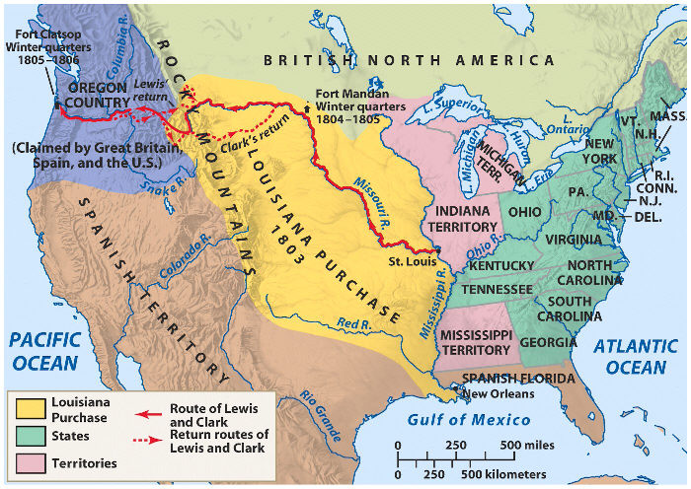
- What are the natural features that mark the boundary of the Louisiana Purchase?

- What is one GEOGRAPHICAL obstacle that the Lewis and Clark expedition had to overcome?

- Read the following quote and then put it in your own words:
“This war [of 1812], if carried on successfully, will have its advantages.”
— Felix Grundy, Representative from Tennessee, speaking in Congress in December of 1811.

____________________________________________________________________________________
____________________________________________________________________________________

Short Answer: In the following space write down the entire open ended question you will choose to answer on the written portion of the exam. Then on another sheet of paper outline or list all of the main points you will discuss for your open ended question.

