Name: __________________________________________ Period: ____ /20
Chapter 15 Visual Preview
Directions: Answer the following questions to the best of your ability using pages 510 and 511 in your text.
- What is the essential question for this chapter?

- What is the approximate time span we will be dealing with? (from what year to what year)

- Looking at the key what does a blue color represent for a state? What does a grey color represent for a state?

- Where are the majority of the battle sites located?

- Why is there Union warships surrounding the South’s entire coastline? What is this called?

- When looking at the chart Union and Confederate Resources, which resource is the only one that the Confederacy has more of?

- Looking at the timeline, when do the first eleven states secede from the Union?

- There is one major Civil War battle located in Pennsylvania, where did it occur?

- What did merchants in the South export? In exchange what are some things they would get from other nations?

- Identify three of the territories on the map that are today states?
-
-
-

- Looking at the timeline, when does Lincoln announce a plan of emancipation?

- List three of the world events listed on the timeline.
-
-
-
- Looking at the timeline, when does the Battle of Gettysburg happen?

- What two oceans are visible on this map? What continent is visible on this map?

- Looking at the timeline, when does Lee surrender? Where did he surrender at?

- Below is a picture taken during the Civil War which shows a Union supply train. How was the railroad useful to warfare during this time period? Which side had the advantage in terms or who had more track then the other? Answer with 3 complete sentences.
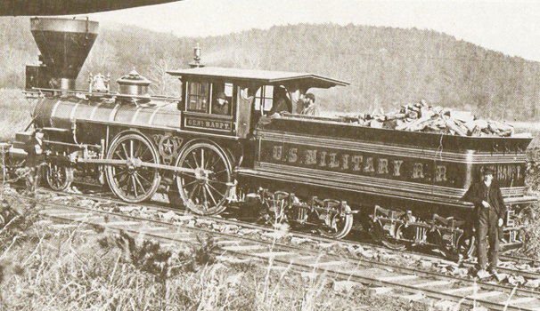
- Identify two events that led to the American Civil War and explain why they increased tensions between the North and the South.

